Alfredo Jose G. Siangio Jr.

TW03

1. Give at least five of your favorite websites and identify the components/parts of the given URL.

 1) <https://www.facebook.com/> 2) https://www.instagram.com/ 3) <https://www.youtube.com/> 4) <https://www.reddit.com/> 5) https://www.google.com/

Protocol: https Protocol: https Protocol: https Protocol: https Protocol: https

Subdomain: www. Subdomain: www. Subdomain: www. Subdomain: www. Subdomain: www.

Domain Name: facebook Domain Name: Instagram Domain Name: youtube Domain Name: reddit Domain Name: google

TLD: .com TLD: .com TLD: .com TLD: .com TLD: .com

2. Search and take a screenshot of the websites that have the TLD suffix:

* .eu

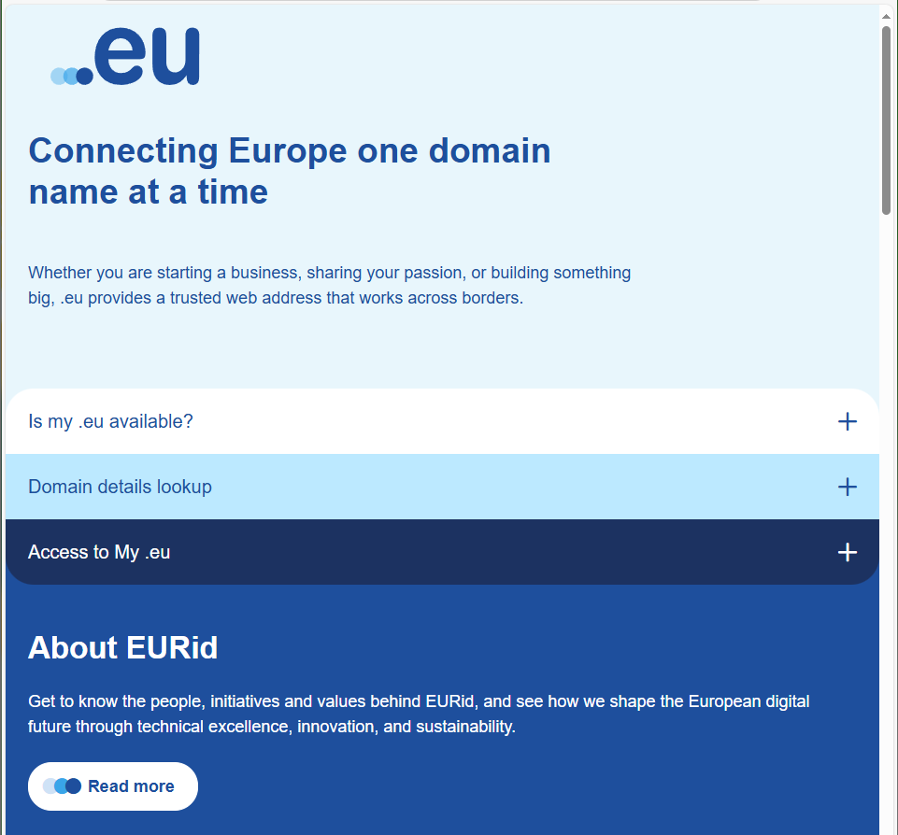

[*https://eurid.eu/en/*](https://eurid.eu/en/)

* .edu

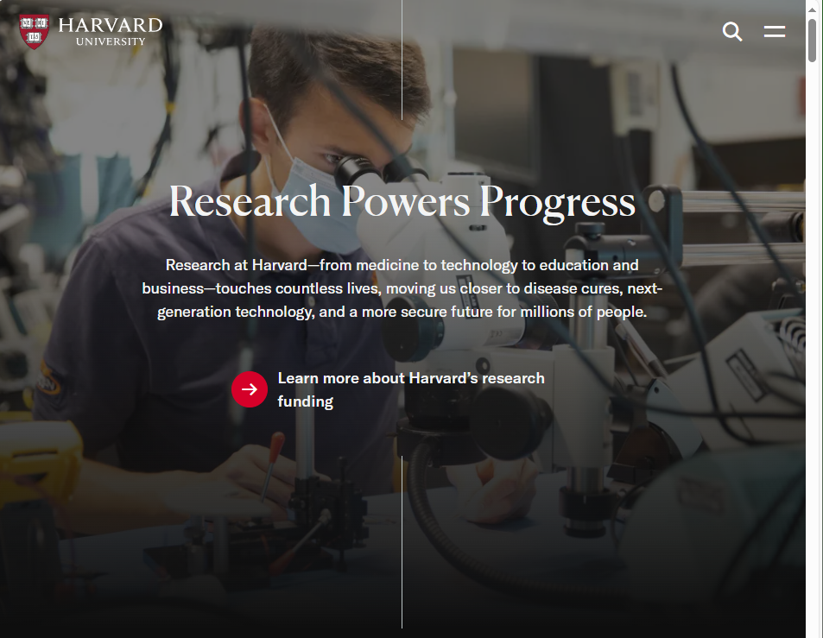

<https://www.harvard.edu>

* .jp

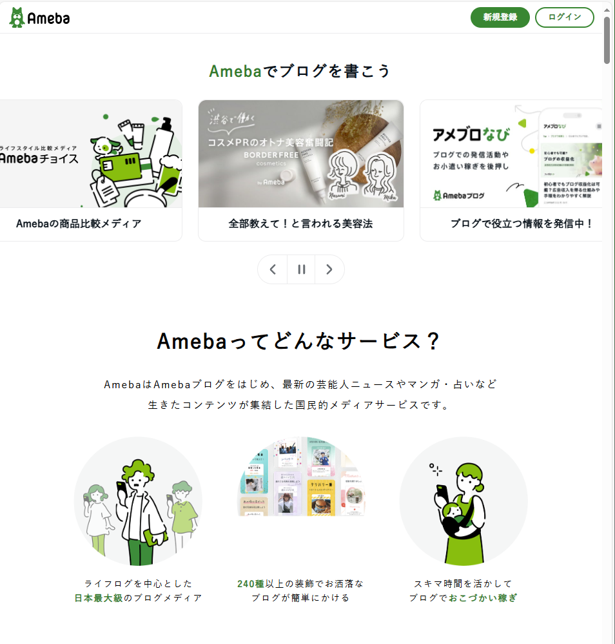

https://ameblo.jp